Transcriptome analysis of flower colour reveals the correlation between SNP and differential expression genes in Phalaenopsis
Yu Ding^{1,#}, Ma-Yin Wang^{1,#}, Ding-Hai Yang^{1,#}, Dai-Cheng Hao², Wei-Shi Li², Peng Ling^{1,*}, Shang-Qian Xie^{1,*}
1. Key Laboratory of Ministry of Education for Genetics and Germplasm Innovation of Tropical Special Trees and Ornamental Plants, College of Forestry Hainan University, Haikou 570228, China
2. Hainan Boda Orchid Technology Co. Ltd. Haikou 570311, China

# These authors contributed equally to this work
* To whom correspondence should be addressed:
Peng Ling, Email: 18389807612@163.com;
Shang-Qian Xie, Email: sqianxie@foxmail.com

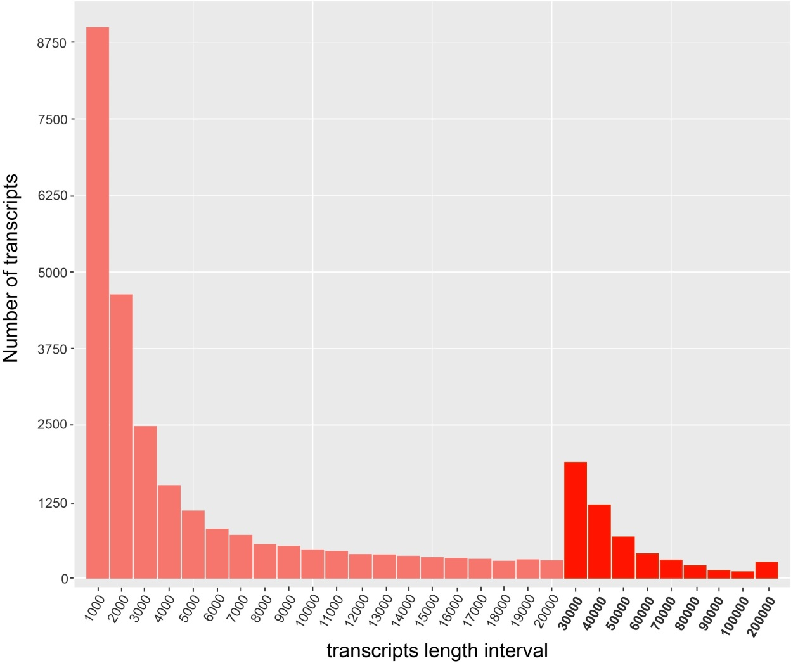
Figure S1 Distribution of transcripts sequences length

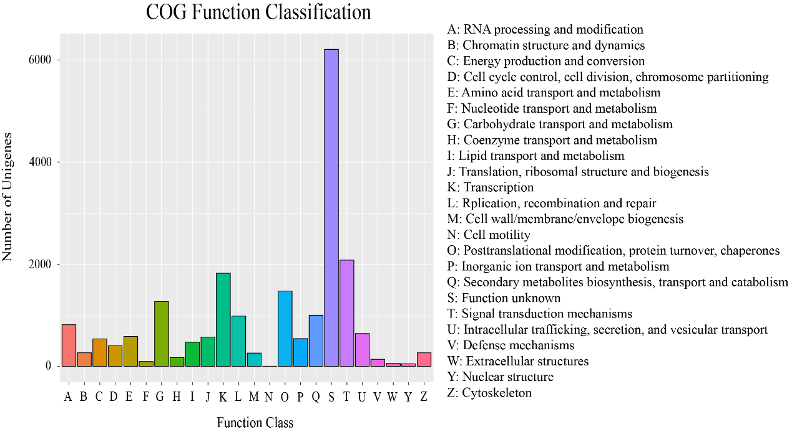
Figure S2 The COG annotation of unigenes

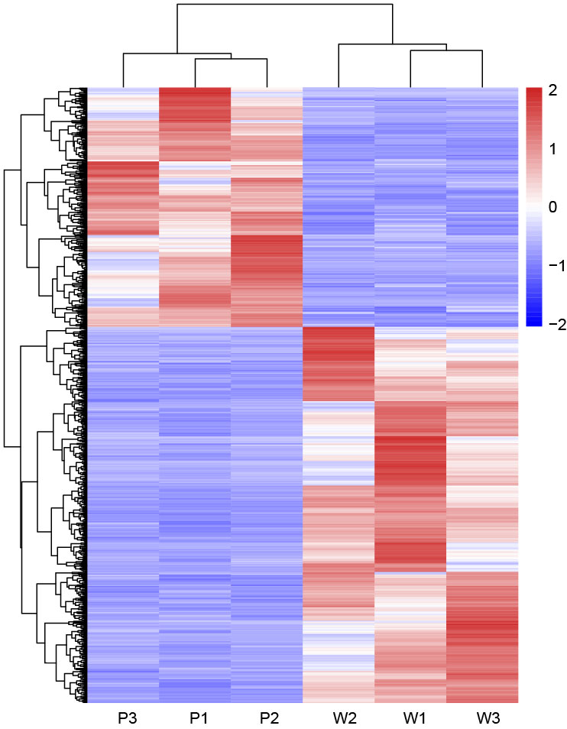
Figure S3 The heatmap of DEGs

Figure S4 The Flavonoid biosynthesis metabolic pathway of DEGs
Figure S5 The phenylpropanoid biosynthesis metabolic pathway of DEGs

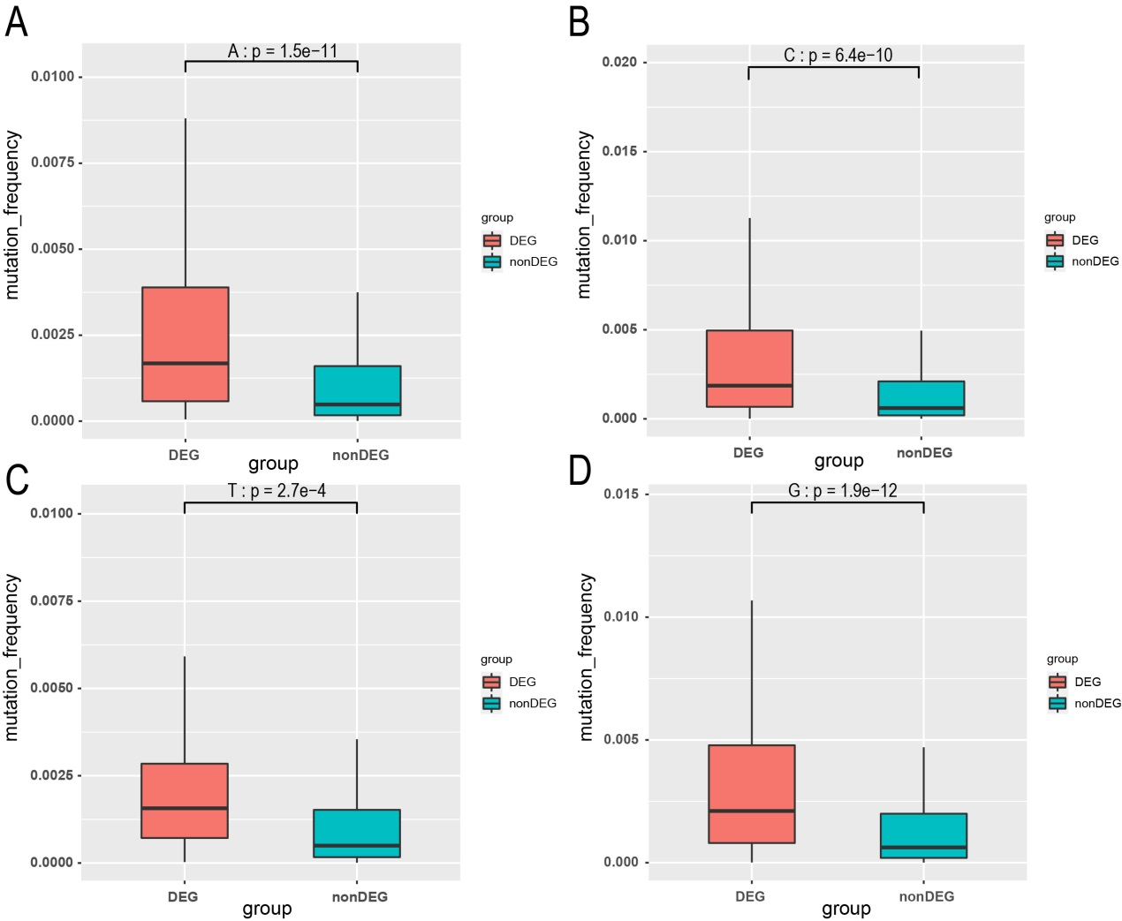
Figure S6 Comparison SNP mutation frequency between DEGs and non-DEGs in A, C, T and G four categories (A: A base; B: C base; C: T base; D: G base)

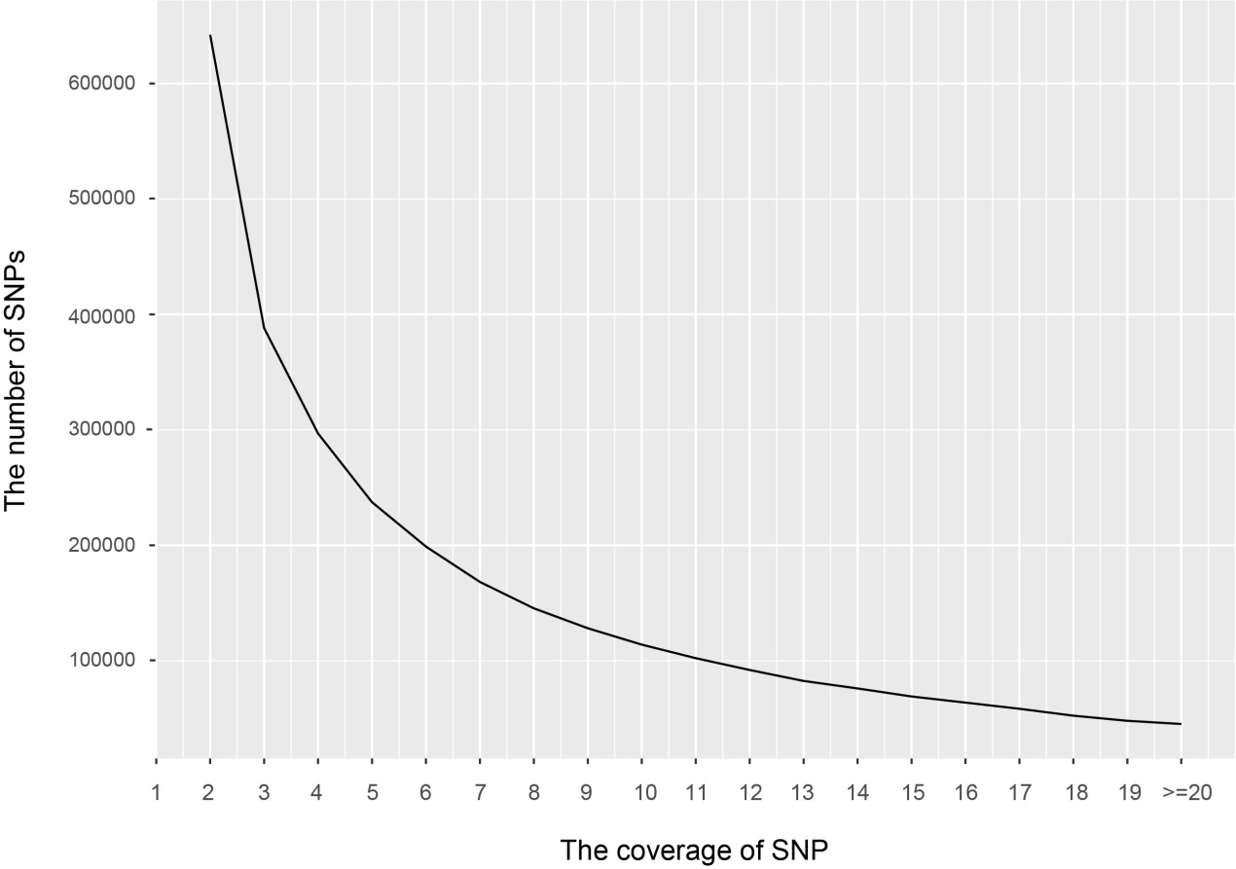
Figure S7 The coverage distribution of SNPs.

